Infectious Disease Response Plan
Cupertino Citizen Corps

12 December 2020, version 1.2

Contents
1 Introduction 3
1.1 Distribution 3
1.2 Goal 3
1.3 Objectives 3
1.4 Scope of impacted operations 3
1.5 Critical Mitigating Elements 4
1.6 Minimizing the Risks 4
1.7 Assessing Risks 5
2 Procedures 6
2.1 General Field Deployment Operations 6
2.2 Changes to ARK Level 3 Operations 7
2.3 Changes to ARK Level 2 Operations 7
2.4 Changes to ARK Level 1 Operations 8
2.5 Changes to Fire Station Operations 9
2.6 Comm 469 Operations 10
2.7 Medical Reserve Corps Operations 10
3 Roles and Responsibilities 11
3.1 Safety Officer, Assistant Safety Officer Checklist 11
3.2 Fixed Field Station Checklist 12
3.3 Individual/Mobile Station Checklist 13
4 Policies 14
4.1 Vehicle Cleaning & Disinfecting Guidance, 14
4.2 Hygiene Procedures 15
4.3 Protocol for Possible Exposure 16
5 Logistics Support 17
5.1 Additional material required at CCC facilities 17
5.2 Responder Go-Kit Requirements 17
5.3 Half page CCC Health Attestation Form 18
A. City Cleaning Supplies Document 19
B. CDC Guidance 21

Introduction
This document is guidance for Cupertino Citizen Corps whenever CCC is activated for a response during an infectious disease or pandemic event.
At the time of this writing, the COVID-19 pandemic is occurring. The loss of life and associated economic and social trauma has been significant. Given the speed of its onset and its expected duration, it is prudent to have a carefully though-out plan in place that guides a CCC emergency response. The complication of such cascading emergencies must be factored into existing response plans to ensure we not only can meet the assigned mission, but also maintain the health and safety of both city responders and community members. Consider an earthquake during a pandemic, or a wildland fire threat during a pandemic. The pandemic element of the response is what must be developed.

Distribution
This plan is distributed to and used by several groups. The CCC will use this plan as the basis for modifying our operations to account for activations with a concurrent infectious disease event. Every CCC member should read and understand this document.
This plan will be distributed to Cupertino OES personnel and other served agencies and organizations. The intent is for these entities to understand how CCC is approaching personal and community health and safety.

Goal
- Protect public and CCC responder health and safety

Objectives
- Protect CCC responders and the community with whom we interact
  - Protect their health and safety.
  - Maximize resources to maintain day-to-day emergency operations.
  - Minimize the virus spread and reduce the impact on CCC and public health.
- Maintain the continuity of response operations
  - Continue day-to-day readiness and response operations to the maximum extent possible throughout all stages of the pandemic.
- Execute the CCC pandemic response
  - Ensure all CCC teams and facilities can fulfill their response responsibilities during a pandemic.
  - Communicate and coordinate pandemic preparedness and response to all City staff and other CCC members.
  - Support the efforts of the City in mitigating the consequences of a pandemic.
  - Do not become part of the problem.

Scope of impacted operations
- General Field Assignments
- ARK Level 3 Operations
- ARK Level 2 Operations
- ARK Level 1 Operations
- Fire Stations Operations
- Comm 469 Operations

Critical Mitigating Elements
Mitigation measures are actions to reduce the negative impacts of situations carrying increased risk through minimizing the severity or scope of impact. Per John Hopkins, Center for Health Security, a modified hierarchy of controls for COVID-19 mitigation measures looks like this:
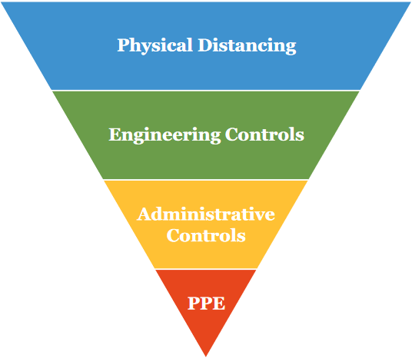
- Physical Distancing — wherever possible, have people respond from home; this should include restructuring responsibilities to minimize the numbers of responders that need to be physically present, and spreading the operational response out over a wider area.
- Engineering controls — creating physical barriers between people.
- Administrative controls — redistributing assignments to reduce contact between individuals, using technology to facilitate communication.
- PPE — having people wear nonmedical cloth masks.

Minimizing the Risks
As science refines its understanding of Pandemics, the following can be generally gleaned from published material as contributing factors that influence the protection from, or spread of, COVID-19.
Time
Most discussions on duration of exposure are aimed at Health Care Professionals (HCP), especially those working in the vicinity of aerosol treatments. The time, or duration, aspect of a contact also comes into play when physical distancing requirements cannot be maintained.
Environmental considerations must be considered when thinking of the time component of risk. Spaces with poor air circulation (rooms with poor on no ventilation) may result in a build-up of airborne viral matter that increases the likelihood of an infection. Conversely, spaces with good air circulation (spaces with open doors and windows, being outside) reduce the viral load by dispersing it over it a wider area.
CCC Action Plan
- Do not engage in activities similar to those of HCP (be prepared to render First Aid if safe; do so with proper PPE).
- Maximize the use of outdoor spaces whenever possible to maintain good air circulation.
Distance
Limiting close face-to-face contact with others is the best way to reduce the spread of coronavirus disease 2019. Social distancing, also called “physical distancing,” means keeping space between yourself and other people outside of your home. This is one of the best tools we have to avoid being exposed to this virus and help slow its spread.
CDC recommends:
- To practice social or physical distancing, stay at least 6 feet (about 2 arms’ length) from other people.
- Limit close contact with others outside your household in indoor and outdoor spaces. Since people can spread the virus before they know they are sick, it is important to stay away from others when possible, even if you—or they—have no symptoms.
CCC Action Plan
- Adopt and implement social distancing requirements to the fullest extent possible.
- A face covering is required whenever you interface with anyone.
Shielding / PPE
Cloth face coverings are most likely to reduce the spread of COVID-19 when they are widely used by people in public settings.
CDC recommends:
- People wear cloth face coverings in public settings when around people outside of their household, especially when other social distancing measures are difficult to maintain (you wearing a mask protects others from you, not you from others).
CCC Action Plan
- Cloth face covering is required when a CCC responder is near anyone else.
NOTE: Starting June 18 2020, per state order, Californians must wear face coverings in common and public indoor spaces and outdoors when distancing is not possible.

Assessing Risks
In general, the risk spectrum for infections ranges from low to high and is driven by several factors. While it is not the intent to define the risk at a granular level here, the extremes are listed as reference.
Low Risk
- Physical Distancing. Keep at least 6 ft (2 meters) from others in public.
- Reduced gathering size in enclosed spaces
- Outdoor gatherings
- Sufficient ventilation
- Face masks.
High Risk
- Close-up, in-person interaction
- Crowded events
- Poorly ventilated spaces
- People talking loudly, singing
- Prolonged exposure (15 minutes of unprotected exposure with someone less than 6 ft)

Procedures

General Field Deployment Operations
For CARES, deployment activities involve operating a radio in the field for the purpose of making and reporting observations or passing messages by radio on behalf of someone else. These types of assignments include, but are not limited to, Infrastructure Safety Assessment, Ember Watches, and CLEAR (Community Local Emergency Assistance Request) station (Alt911) operations.
Note: A characteristic of CCC deployments is the buddy system. The buddy system is a procedure where two individuals, the "buddies", operate together as a single unit so that they are able to monitor and help each other. During a pandemic, this is problematic for field teams who may not be part of the same household.
During a declared health emergency involving an infectious disease and at the direction of the Citizen Corps Coordinator or Cupertino OES, the following general changes are in effect for all field operations:
- A Safety Officer will be designated, either as a dedicated position or in conjunction with other assigned duties.
- All responders will exercise social distancing by maintaining a minimum six-foot distance between responders and the public at all times, except as strictly necessary to carry out a task associated with the response mission (examples: retrieving tables, reviewing a common document, etc.).
- The time of any close contact should be minimized as much as possible.
- The need for close contact is when it is strictly necessary and in agreement between the individuals converging within 6 feet.
- A cloth face covering will be worn when around people outside of their household. This is especially important when other social distancing measures are difficult to maintain.
- CCC members should recruit other household members as their Buddy. Household members should be sworn in as DSW workers now, or prior to any field deployment.
- If two CCC responders (not of the same household) are responding to the same remote location, then two vehicles should be used.
- For CARES, the Shift Supervisor consults the resource readiness list for pre-identified members interested in single-person assignments.
- For CARES, at the discretion of the Shift Supervisor and with the consent of the individual, specific low-risk assignments can be made to an individual as a team of one.
- For field stations where interaction with the public is expected, sufficient barriers (tables, chairs, caution tapes, etc.) should be used to ensure appropriate social distancing is maintained. Staffing should be sufficient to allow one individual to enforce all County and City rules for social distancing.
- Regular cleaning occurs by incoming and outgoing shifts.
- All standard safety procedures apply.
- If you are not comfortable with your surroundings or the assignment, let your supervisor know.
- Personal emergency response equipment must not be shared while on assignment.
- Assigned equipment (radios, first aid equipment, etc.) should be handled as personal equipment during a shift and will not be reassigned until appropriate decontamination procedures have occurred.

Changes to ARK Level 3 Operations
The goal of a Level 3 Activation is to establish Cupertino Zone Reporting locations for collecting reports and determining the extent of the problems that may exist within a specific reporting zone.
During a declared health emergency involving an infectious disease and at the direction of the Citizen Corps Coordinator or Cupertino OES, the following specific changes are in effect for ARK Level 3 operations:
- All Section 2.1 General Field Deployment Operations changes apply.
- Hand sanitizers or handwashing should be used after all close public interaction where things were mutually handled.

Changes to ARK Level 2 Operations
The goal of a Level 2 Activation is to (i) continue ARK Level 3 activation activities, (ii) maintain two-way communications with the DOC, and (iii) pass information, requests, and status on what is happening at the ARK location. As a public-facing assignment, Level 2 Ops will require a greater attention to physical distancing given the need to interact with the general public.
During a declared health emergency involving an infectious disease and at the direction of the Citizen Corps Coordinator or Cupertino OES, the following specific changes are in effect for ARK Level 2 operations:
- All Section 2.1 General Field Deployment Operations changes apply.
- Check-ins will be recorded by one individual.
- Radio operations will be established with sufficient space to accommodate all required communications needs while meeting the physical distancing requirements.
- Additional tables and spacing to ensure 6 feet between the communications staff and approaching public will constitute a Physical barrier. Additional boundaries will be established. with deploying popup side panels and using yellow caution tape attached to chairs, traffic cones, or other supports.
- For Alt911 reports,
  - public interaction should be minimized by having a Level 2 ARK staff member write down the report.
  - If a public member does fill out an Alt911 message form, there should be minimum handling of the form by staff, followed by placing the form in a secure location (envelope, box, other).
  - Reusable items handled by the public should be wiped down before putting back in use.
- Hand sanitizers or handwashing should be used after all close public interaction where things were mutually handled.

Changes to ARK Level 1 Operations
The goal of a Level 1 Activation is to establish a formal Incident Command Post at a specific location. As a public-facing assignment, Level 1 Ops will require a greater attention to physical distancing given the need to interact with the general public.
During a declared health emergency involving an infectious disease and at the direction of the Citizen Corps Coordinator or Cupertino OES, the following specific changes are in effect for ARK Level 1 operations:
- All Section 2.1 General Field Deployment Operations changes apply.
- All responders are to abide by the latest Health Agency and Government regulations (wearing face masks, keeping a minimum of 6ft physical distance, etc.)
- No one is permitted into the Incident Response Area (see picture for definition) until approved by the Safety Officer or Assistant to the Safety Officer.
- Each station will deploy two tables to keep 6 ft separation between the “customer” and volunteer(s).
- Use yellow tape to cordon off working areas (use chairs to hold up the tape as needed).
- For additional safety of ICP personnel, deploy canopies with canopy walls keeping the walls/curtains a couple of feet off the ground to allow for air circulation.
- Keep in mind the wind conditions when selecting a location for setting up the ARK.
- Each station table must have a bottle of hand disinfectant and a box of sanitizing wipes (to wipe work surfaces).
- Pens should be retained by volunteers for their personal use for the duration of their shift.
- Each station table must have two containers for pens (cups, small boxes, jars, etc.): One labeled “CLEAN” and the other “USED”. This is to limit handling of pens by different users. Once a user is done filling out a form(s), the user places his/her pen in the container labeled “USED”. As the supply of clean pens goes down, a designated volunteer will sanitize the pens in the “USED” container and replenish the “CLEAN” container.
- Minimum handling of public-generated paperwork should be encouraged.
- Only one person allowed to be inside the ARK (container/garage) at any given time. The IC will designate the “official” ARK person who will be responsible for bringing the required item(s) to the ARK entrance for the requester to carry to the needed station. The designated ARK person must be able to move tables, generators, chairs, etc. by himself/herself. The same process will be used upon demob.
- No food or drink will be provided as in past deployments or exercises; each volunteer to bring his/her own food and drink.
- Each volunteer is required to have the following additional items in their Go Kits:
  - PPE (mask, nitrile gloves, eye protection)
- Each volunteer is encouraged to have the following additional items in their Go Kits:
  - hand sanitizer, and
  - surface disinfectant wipes.

General Level 1 Process Flow
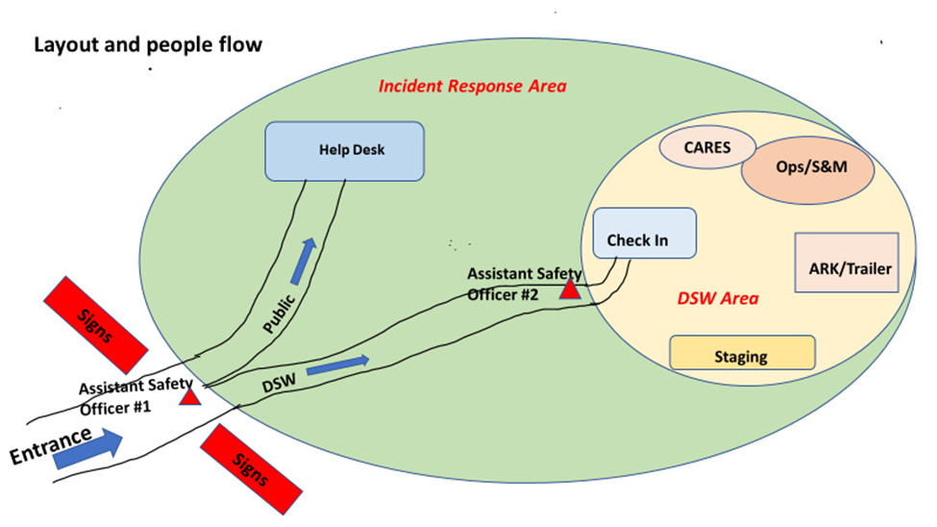
- Each person arriving at the Incident Response area must pass through a check-point staffed by an Assistant Safety Officer (ASO#1 in the picture).
- Above necessitates a single-entry path, marked by signs and yellow tape (see picture).
- Person approaches, the Assistant Safety Officer #1 intercepts, and:
- Ensures person is wearing a mask, if no mask a mask will be provided at that point.
- Asks if person is a volunteer or a member of the general public.
- If not a volunteer, directs the person to the Help Desk.
- If a volunteer, directs the person to the Assistant Safety Officer #2 at the entrance to the DSW area (the Command Post).
- Person approaches, the Assistant Safety Officer #2 intercepts, and:
- Checks if he/she is a registered DSW. If yes, proceed. If no, turn away.
- Asks he/she to fill in the 901 form.
- Form is checked, then dropped into an envelope.
- Takes the temperature.
- For any condition that is not satisfactorily met, the would be volunteer is turned away.
- If all conditions are satisfactorily met, the volunteer is cleared to go to the Check-in Desk.

Changes to Fire Station Operations
County Fire recognizes that during an emergency, (i) all fire apparatus will be deployed addressing the emergency, and (ii) fire stations will be likely places where residents in need will converge looking for help. Both CARES and CERT responders will operate from these stations to take resident reports or requests for assistance and pass them on.
During a declared health emergency involving an infectious disease and at the direction of the Citizen Corps Coordinator or Cupertino OES, the following specific changes are in effect for Fire Stations operations:
- All Section 2.1 General Field Deployment Operations changes apply.
- Check-ins will be recorded by one individual.
- Only one CARES radio operator will be permitted to operate in the Fire Station lobby at a time.
- One or more public facing team members will establish a workspace outside the station in the vicinity of the station lobby. Caution tape and other measures will be used to ensure physical distancing requirements are maintained with the public.
- Message handoff from the public-facing team member to the radio operator will be done by radio or written message.
- This plan must be reviewed and approved by Santa Clara County Fire.

Comm 469 Operations
During a declared health emergency involving an infectious disease and at the direction of the Citizen Corps Coordinator or Cupertino OES, the following specific changes are in effect for all Comm 469 operations:
- All Section 2.1 General Field Deployment Operations changes apply.
- Check-ins will be recorded by one individual.
- Only one individual will occupy the Comm 469 cab at a time. Supporting staff will follow in separate vehicles.
- When deployed, all vehicle operating compartment doors and roof vent will be open for increased air circulation. If possible, park the van with side or rear door facing into the wind to boost air circulation.
- Only two operating positions will be staffed inside Comm 469 at a time: Radio Room Operator (P3) and Shift Supervisor (P4).
- Two operating positions will be staffed outside Comm 469: Resource Net (P1) and SCC County voice net/Packet (P2).
- Two pop-ups with sides will be deployed to shade outside operating positions. Positions include a table and chair for each position. Consideration should be given to workstation orientation, proximity to the generator, sun track, and prevailing winds.
- Traffic cones and caution tape will be used to mark minimum 6 ft physical distancing zones from fixed operators or outside meeting areas.
- Outside workstation placement specifics will depend on the deployment location.

Medical Reserve Corps Operations
- Medical treatment area is to be included within the Incident response area referenced in 2.4 section of this document; PENDING.
- Medical TRIAGE, Check-In, Treatment, Transportation areas will follow infectious disease protocols as called out in out American Heart Association First Aid Training and supplemented by any specific County, State or Federal guidelines as they apply.

Roles and Responsibilities

Safety Officer, Assistant Safety Officer Checklist
All field deployment locations will have a designated Safety Officer named. This may be a dedicated or shared position depending on the number of people at a specific location.
Checklist – Safety Officer, Pandemic Health Component
This checklist is relevant for assignments associated with all CCC deployments during a pandemic where two or more responders are co-located to perform a specific event task.
Before the Event
______ | - Knows the City and CCC policies and procedures for field operations during a Pandemic.
______ | - Understands the Check-In procedure to be followed at all field sites including PPE, Temperature check, and health survey collection requirements.
______ | - Understands the process of where to get replacement PPE and cleaning material as needed.
During the Event
______ | - Manage the placement of the ARK in terms of wind direction (CERT Training: go upwind, uphill, or upstream)
______ | - Clean work areas before and after assignment.
______ | - Provides daily health and safety briefing; include updates on rules and procedures.
______ | - Verifies all responders have the required PPE items.
______ | - Performs and records the temperature check for incoming staff.
______ | - Ensures all responders complete the Facility check-in (health attestation) form.
______ | - Signs in on ICS211.
______ | - Provides active feedback and corrective action when deviations from policies are observed. Responders who do not follow policy guidelines will be relieved of their assignment.
______ | - Provide the site IC and DOC with periodic updates on the state of compliance (a component of Situation Status).
______ | - Performs temperature check on arrival and after 4 hours. If a temperature check fails  (> 100.4ºF), then it is recorded on the Safety Officer’s ICS 214 and the person is sent home.
After the Event
______ | - Submit all health attestation forms to City EOC (include these documents as part of Demob to be submitted to the Planning Section).
Shift Change (Include in the ICS 201 Incident Briefing created by the outgoing IC)
Before turning over or accepting a shift, both the in-coming and out-going Safety Officer should review as much information as possible, including:
- Status of Pandemic protocol compliance, deviations, action plans
- What is going on in general? What changes are expected?
- Attend the all-hands briefing that occurs during each shift change if offered.

Fixed Field Station Checklist
A fixed field station is a radio station set up at either a pre-defined facility or ad-hoc location where communications station infrastructure is put in place (coverage, tables, chairs, power, etc.). This checklist covers Fixed Field Stations.
Checklist
This checklist is relevant for all CCC responders during an infectious disease event where two or more responders are co-located at a fixed field station to perform a specific event task.
Before the Event
______ | - Responders confirm Go-Kit readiness including enhanced PPE items.
During the Event
______ | - Clean work areas before and after assignment.
______ | - For assignments with 2 or more responders, identify one as the Safety Officer. This responsibility may be in addition to some other operational assignment.
______ | - Station set up  - Masks are mandatory  - Establish an ICS 211 check-in Sheet for all station responders (CARES, CERT, MRC).  - A designated responder will manage recording all check-in names on the ICS 211.  - Operating positions are separate as much as possible.  - All public facing functions to have additional space that is clearly marked.
______ | - Public Interaction:  - Public approaching the station must be wearing mask and kept at least 6 feet from field staff.  - In the event unmasked public approaches the station, even greater distance is required. Pass items – clipboard, pens, paper – in a manner that insures no contact.
______ | - Outgoing Shift performs a full wipe down. Remove any disposable covers from shared equipment such as headphones, microphones or other.
After the Event
______ | - Submit all infectious disease-related paperwork to the City EOC (include these documents as part of Demob to be submitted to the Planning Section).
______ | - Continue to observe the infectious disease protocol when breaking down any field station.
NOTES
…

Individual/Mobile Station Checklist
An Individual/mobile station is where the operator uses an HT (Hand Talkie) or automobile-based mobile radio to pass radio traffic. This checklist covers Individual Field Stations.
Checklist
This checklist is relevant for all CARES responders during an infectious disease event where two or more responders are co-located at a fixed field station to perform a specific event task.
Before the Event
______ | - Responders confirm Go-Kit readiness including enhanced PPE items.
During the Event
______ | - Cloth face masks are mandatory whenever you are in close proximity of another person.
______ | - Maintain physical distance from any person that you encounter.
After the Event
______ | - On completion of your assignment, submit all infectious disease-related paperwork to the City EOC (include these documents as part of Demob to be submitted to the Planning Section).
______ | - Performs a full wipe down of your equipment. Replenish your stock any protection equipment as necessary.
NOTES

Policies

Vehicle Cleaning & Disinfecting Guidance,
The following guidance is adapted by CARES.
What to Do
- Sanitize frequently touched vehicle surfaces on a regular basis.
- Be mindful of the cleaning / disinfecting agents used on vehicles to avoid inadvertently damaging the interior or exterior.
  - Many of the same household cleaners (such as non-bleach, unscented, non-chlorinated disinfectant cleaners and wipes) that kill coronaviruses on hard surfaces at home can also clean most vehicle interiors without causing damage.
  - Alcohol solutions at least 70 percent alcohol are effective against coronavirus. Nearly every interior surface of a vehicle can be cleaned with isopropyl alcohol.
  - Vigorous washing with soap and water can also destroy a coronavirus. Soap and water are safe for most vehicle interiors. Be careful not to saturate the surfaces.
- Follow the cleaning agent manufacturer’s product label guidance for the recommended disinfecting procedure, as guidance varies by cleaning product.
- When using wipes, remove excess liquid before wiping surfaces, especially electrical components and touch screens.
Vehicle Cab / High Touch Areas
- Car keys and fobs
- Door and storage compartment handles, latches and lock buttons
- Steering wheel
- Shift lever
- Emergency break release
- Any buttons or touch screens (radios, mirror adjusters, climate controls, etc.)
- Wiper and turn signal controls
- Seat controls (front/back, control to tilt the seat)
- Center console and cup holders
- Driver and passenger armrests, seat belts, grab handles, and seat adjusters
- Headrests and seat pockets
Comm 469-specific areas
- Work surfaces
- Radios, telephones
- Computer keyboards, mouse
- Arms of chairs and top of chair where hands are used to move the chair
- Wheel handle used to raise and lower roof vent, vent controls
- Circuit breakers
- External rails on exterior ladder and by access doors

Hygiene Procedures
The following procedure is adapted by CCC.
Measures for protecting volunteers from exposure to, and infection with COVID-19, depend on the type of work being performed and exposure risk. This includes the potential for interaction with people with suspected or confirmed COVID-19 and contamination of the work environment.
OSHA has developed this interim guidance to help prevent worker exposure to SARS-CoV-2. The general guidance below applies to all U.S. workers and employers. Depending on where their operations fall in OSHA's exposure risk hierarchy, volunteers and supervisors should also consult additional, specific guidance for those at increased risk of exposure in the course of their job duties broken down by exposure risk level.
For all CCC responders, regardless of specific exposure risks, it is always a good practice to:
- Wear a mask.
- Frequently wash your hands with soap and water for at least 20 seconds. When soap and running water are unavailable, use an alcohol-based hand rub with at least 60% alcohol. Always wash hands that are visibly soiled.
- Avoid touching your eyes, nose, or mouth with unwashed hands.
- Practice good respiratory etiquette, including covering coughs and sneezes.
- Avoid close contact with people who are sick.
- Stay home if sick.
- Recognize personal risk factors. According to U.S. Centers for Disease Control and Prevention (CDC), certain people, including older adults and those with underlying conditions such as heart or lung disease or diabetes, are at higher risk for developing more serious complications from COVID-19.

Protocol for Possible Exposure
The following protocol is adapted by CCC.
NOTE: Claims DSWVP or City insurance: all injuries and possible exposures are to be reported to Supervisor which will contact Citizen Corps Coordinator. Citizen Corps Coordinator will follow City incident reporting procedures with City’s Human Resources talking the lead in reporting, contact tracking, and claims processing.
No one wants to get sick, much less exposed. However, in the event this does occur, the individual at risk should follow these recommendations from the Center for Disease Control and Prevention on Public Health Guidance for Community-Related Exposure.
Person | Exposure To | Recommended Precautions
Individual who has had close contact (< 6 ft) for 15 minutes or more | - Person with COVID-19 who has symptoms (in the period from 2 days before symptom onset until they meet criteria for discontinuing home isolation)  - Person who has tested positive for COVID-19 (laboratory confirmed) but has not had any symptoms (in the 2 days before the date of specimen collection until they meet criteria for discontinuing home isolation) | - Stay home until 14 days after last exposure and maintain social distance (at least 6 feet) from others at all times  - Self-monitor for symptoms  - Check temperature twice a day  - Watch for fever, cough, or shortness of breath, or other symptoms of COVID-19  - Avoid contact with people at higher risk for severe illness from COVID-19  - Follow CDC or County Health guidance if symptoms develop

Logistics Support

Additional material required at CCC facilities
The following Pandemic support material will be used at all CCC deployment locations (ARKs, Comm 469, etc.):
- COES 901 Facility Check-in (health attestation) form
- Contactless Thermometer
- Cleaning supplies
- Signage (standard “Face covering mandatory and stay 6ft apart”)
- Contact tracing logs (ICS211, ICS214, Comm Logs, T-Cards, other)
- Separate set of pens for public use
- Hand sanitizer
- Disinfectant Wipes
- Field ops process update
- Portable (or 12vdc) mini-Public Address systems

Responder Go-Kit Requirements
The following additional CCC Responder Go-Kit items are required:
- Cloth face mask
- Eye protection
- Nitrile gloves, at least 2 pair
The following additional CCC Responder Go-Kit items are recommended:
- Hand sanitizer
- Sanitizing wipes
- Face shield

Half page CCC Health Attestation Form
Pads of this half-page form will be produced and available at all CCC Facilities.
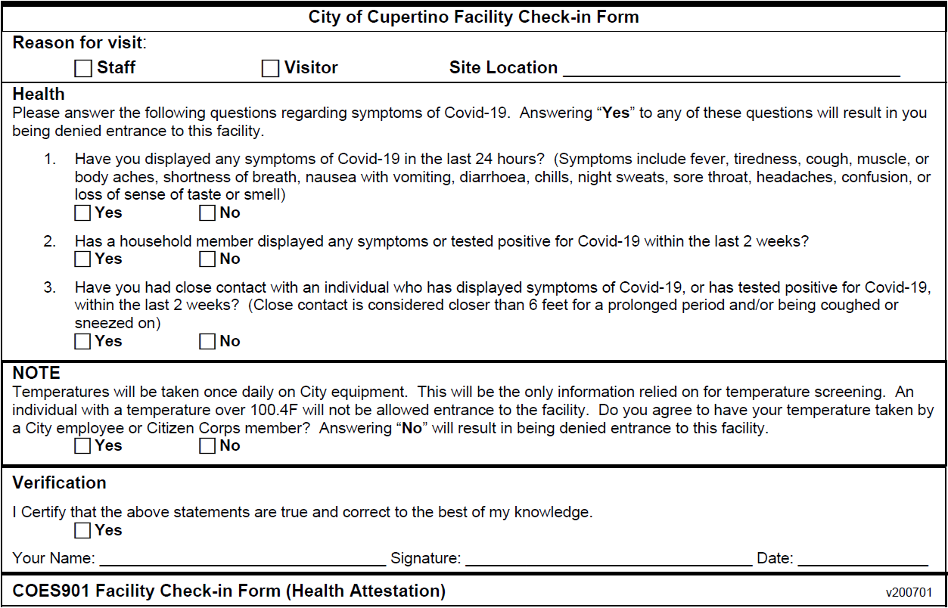

City Cleaning Supplies Document
From: Cupertino Sustainability
Sent: Friday, May 29, 2020 4:29 PM
To: Cupertino OES
Subject: RE: Sustainable Cleaning Products

Thanks for checking, Tom.
Our partners at the Green Business network put together the following list, these are taken from the EPA’s list and shortened to find the environmentally safer options, we would prefer to stick to this short list for cleaning products, because that is one of the requirements of our GreenBiz certification and also found to be safer for the people using the product.
See below:
SAFER OPTIONS
US EPA has released a list of recommended disinfectants that are approved for use against SARS-CoV-2, the virus that causes COVID-19. Disinfectants are designed to kill germs, and therefore none can be completely harmless. Because of this, the US EPA does not allow manufacturers to label disinfectant solutions with third-party certifications, such as Green Seal. However, there are safer options out there.
When considering EPA’s list, Green Seal recommends choosing products with the following active ingredients:
- hydrogen peroxide**
- citric acid
- lactic acid
- ethyl alcohol (also called ethanol or just alcohol), or
- isopropyl alcohol
- peroxyacetic acid**
- sodium bisulfate

US EPA’s Design for the Environment program has reviewed and approved these active disinfectant ingredients as being unlikely to have carcinogenic or endocrine disruptor properties and as unlikely to cause developmental, reproductive, mutagenic, or neurotoxicity issues. In addition to these 7 chemicals, hypochlorous acid, which is typically generated by a device on-site rather than sold off the shelf, is a disinfectant with a similar toxicity profile to the ingredients approved by EPA’s Design for the Environment program.
On EPA's comprehensive list of recommended disinfectants for COVID-19, the agency includes several products with these active ingredients, including:
- Force of Nature Activator Capsule*** (EPA Registration No. 93040-1) (10-minute contact time)
- EnvirOx Critical Care (Registered under the name Axen(R) 30) (EPA Registration No. 72977-3) (3-minute contact time)
- Clorox Commercial Solutions Hydrogen Peroxide Disinfecting Cleaner and Clorox Healthcare Hydrogen Peroxide Cleaner Disinfectant (EPA Registration No. 67619-24) (1-minute contact time)
- Diversey’s Oxivir Wipes (EPA Registration No. 70627-60) (1-minute contact time)
- GOJO Industries PURELL Multi-Surface Disinfecting Cleaner, PURELL Multi Surface Disinfectant and PURELL Professional Surface Disinfectant (registered under the name URTHPro) (EPA Registration No. 84368-1) (1-minute contact time)
- Ecolab’s Peroxide Multi Surface Cleaner and Disinfectant (EPA Registration No. 1677-238) (2-minute contact time)
- Ecolab’s Peroxide Disinfectant and Glass Cleaner RTU (EPA Registration No. 1677-251) (.75 minute contact time)
- Clorox Pet Solutions Advanced Formula Disinfecting Stain & Odor Remover (EPA Registration No. 5813-110) (5-minute contact time)
- Clorox Commercial Solutions® Hydrogen Peroxide Cleaner Disinfectant Wipes and Clorox Healthcare Hydrogen Peroxide Cleaner Disinfectant Wipes (EPA Registration No. 67619-25) (2-minute contact time)
- Diversey’s Oxivir TB Ready-to-Use Liquid (EPA Registration No. 70627-56) (1-minute contact time) (1-minute contact time)
- Diversey’s Oxivir Five 16 (registered under the name Oxy-Team Disinfectant) (EPA Registration No. 70627-58) (5-minute contact time)
- Diversey’s Alpha HP Multi-Surface Disinfectant Cleaner (registered under the name Phato 1:64 Disinfectant Cleaner) (EPA Registration No. 70627-62) (5-minute contact time)
- Lysol Disinfecting Bathroom Cleaner (EPA Registration No. 675-55) (5-minute contact time)
- GOJO Industries PURELL Professional Surface Disinfecting Wipes (EPA Registration No. 84150-1) (5-minute contact time)

In addition to choosing the active ingredient that you are the most comfortable with, it is important to look at the safety of the overall disinfectant product, including inactive ingredients. The product safety data sheet (SDS) provides information on whether the overall product is classified as hazardous according to OSHA (Occupational Safety and Health Administration). The SDS also includes information on protective measures and safety precautions for using the product. As always, read the label carefully and follow the directions for safe, effective use.

CDC Guidance
- [CDC] now know[s] from recent studies that a significant portion of individuals with coronavirus lack symptoms (“asymptomatic”) and that even those who eventually develop symptoms (“pre-symptomatic”) can transmit the virus to others before showing symptoms. This means that the virus can spread between people interacting in close proximity—for example, speaking, coughing, or sneezing—even if those people are not exhibiting symptoms.
- CDC recommends wearing cloth face coverings in public settings where other social distancing measures are difficult to maintain (e.g., grocery stores and pharmacies) especially in areas of significant community-based transmission.
- … maintaining 6-feet social distancing remains important to slowing the spread of the virus.
Classifying Risk of Volunteer Exposure to COVID-19
According to the CDC, certain people, including older adults and those with underlying conditions such as heart or lung disease or diabetes, are at higher risk for developing more serious complications from COVID-19.
Worker risk of occupational exposure to SARS-CoV-2 during a pandemic may depend in part on the industry type and the need for contact within 6 feet of people known to be, or suspected of being, infected with SARS-CoV-2. Other factors, such as conditions in communities where employees live and work, their activities outside of work (including travel to COVID-19-affected areas), and individual health conditions, may also affect workers' risk of getting COVID-19 and/or developing complications from the illness.
OSHA has divided job tasks into four risk exposure levels: very high, high, medium, and lower risk. The four exposure risk levels represent the probable distribution of risk. Most Citizen Corps volunteers will likely fall in the lower exposure risk (caution) or medium exposure risk levels. These categories have been adapted from OSHA description of risk.
Lower Exposure Risk (Caution)
Jobs that do not require contact with people known to be, or suspected of being, infected with SARS-CoV-2. Workers in this category have minimal occupational contact with the public and other coworkers. Examples include:
- Remote volunteers (i.e., those working from home during the pandemic).
- Volunteers who do not have frequent close contact with coworkers, customers, or the public.
- Field volunteers who do not have frequent close contact with coworkers, customers, or the public.
- Long-distance truck drivers
Medium Exposure Risk
Jobs that require frequent/close contact with people who may be infected, but who are not known to have or suspected of having COVID-19. Volunteers in this category include:
- Those who may have contact with the general public (e.g., ARKs, Fire Stations, Community information outreach locations, schools).
High Exposure Risk
Jobs with a high potential for exposure to known or suspected sources of SARS-CoV-2. Volunteers in this category include.
- MRC first aid, healthcare delivery and support staff exposed to known or suspected COVID-19 patients.
Very High Exposure Risk
Jobs with a very high potential for exposure to known or suspected sources of SARS-CoV-2 during specific medical, postmortem, or laboratory procedures.

https://www.centerforhealthsecurity.org/our-work/pubs_archive/pubs-pdfs/2020/200417-reopening-guidance-governors.pdf, Public Health Principles for a Phased Reopening During COVID-19: Guidance for Governors, April 17, 2020, John Hopkins, Center for Health Security
https://www.cdc.gov/coronavirus/2019-ncov/prevent-getting-sick/social-distancing.html, CDC, Social Distancing
https://www.cdc.gov/coronavirus/2019-ncov/prevent-getting-sick/cloth-face-cover-guidance.html, Considerations for Wearing Cloth Face Coverings, CDC
https://covid19.ca.gov/, California State order on Face Masks
Adapted from ‘https://www.sccgov.org/sites/covid19/Documents/Appendix-B1-Small-Projects-06-05-20.pdf’, Sections 2.e, 2.k, SCC PHD, June 5, 2020
If two cars as is used for the same assignment, then each must have communications capability.
Usually assigned to more experienced individuals.
https://www.gsa.gov/cdnstatic/GSA%20Vehicle%20Cleaning%20%20Disinfecting%20Guidance%20for%20COVID-19.pdf, GSA Fleet Vehicle Cleaning & Disinfecting Guidance for COVID-19, GSA
See Appendix •A City Cleaning Supplies Document, Andre Duurvoort, City of Cupertino, May 29 2020
https://www.osha.gov/SLTC/covid-19/controlprevention.html, COVID-19 Control and Prevention, Occupational Safety and Health Administration
https://www.cdc.gov/coronavirus/2019-ncov/php/public-health-recommendations.html, Public Health Guidance for Community-Related Exposure, CDC
Data to inform the definition of close contact are limited. Factors to consider when defining close contact include proximity, the duration of exposure (e.g., longer exposure time likely increases exposure risk), and whether the exposure was to a person with symptoms (e.g., coughing likely increases exposure risk).
Data are insufficient to precisely define the duration of time that constitutes a prolonged exposure. Recommendations vary on the length of time of exposure, but 15 minutes of close exposure can be used as an operational definition. Brief interactions are less likely to result in transmission; however, symptoms and the type of interaction (e.g., did the infected person cough directly into the face of the exposed individual) remain important.
https://www.cdc.gov/coronavirus/2019-ncov/hcp/disposition-in-home-patients.html, Discontinuation of Isolation for Persons with COVID -19 Not in Healthcare Settings, CDC
Fever is defined as subjective fever (feeling feverish) or a measured temperature of 100.4°F (38°C) or higher. Note that fever may be intermittent or may not be present in some people, such as those who are elderly, immunocompromised, or taking certain fever-reducing medications.
https://www.cdc.gov/coronavirus/2019-ncov/need-extra-precautions/people-at-higher-risk.html, People Who Are at Higher Risk for Severe Illness, CDC
Recommendation Regarding the Use of Cloth Face Coverings, Especially in Areas of Significant Community-Based Transmission
https://www.osha.gov/SLTC/covid-19/hazardrecognition.html#risk_classification, Hazard Recognition, Occupational Safety and Health Administration

